System call fork() is used to create processes. It takes no arguments and returns a process ID. The purpose of fork() is to create a new process, which becomes the child process of the caller. After a new child process is created, both processes will execute the next instruction following the fork() system call. Therefore, we have to distinguish the parent from the child. This can be done by testing the returned value of fork():
- If fork() returns a negative value, the creation of a child process was unsuccessful.
- fork() returns a zero to the newly created child process.
- fork() returns a positive value, the process ID of the child process, to the parent.
Normally, the process ID is an integer.
Please note that Unix will make an exact copy of the parent's address space and give it to the child. Therefore, the parent and child processes have separate address spaces.

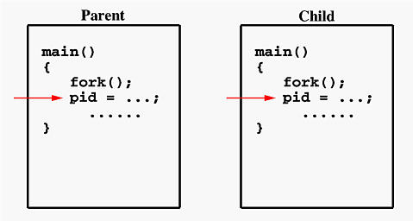

Both processes start their execution right after the system call fork(). Since both processes have identical but separate address spaces, those variables initialized before the fork() call have the same values in both address spaces. Since every process has its own address space, any modifications will be independent of the others. In other words, if the parent changes the value of its variable, the modification will only affect the variable in the parent process's address space. Other address spaces created by fork() calls will not be affected even though they have identical variable names.

Wait()

This function blocks the calling process until one of its child processes exits or a signal is received. For our purpose, we shall ignore signals. wait() takes the address of an integer variable and returns the process ID of the completed process. If there are at least one child processes running when the call to wait() is made, the caller will be blocked until one of its child processes exits. At that moment, the caller resumes its execution.If there is no child process running when the call to wait() is made, then this wait() has no effect at all. That is, it is as if no wait() is there.

Execl()

int execl(const char *path, const char *arg, ...
/* (char *) NULL */);

The exec() family of functions replaces the current process image with a new process image. The const char *arg and subsequent ellipses in the execl(), execlp(), and execle() functions can be thought of as arg0, arg1, ...,
argn. Together they describe a list of one or more pointers to null-terminated strings that represent the argument list available
to the executed program. The first argument, by convention, should point to the filename associated with the file being executed.
The list of arguments must be terminated by a null pointer

